Works – 7 – Paradigmi (Paradigms)

Paradigmi
(Paradigms)
2010
Video
Durata?

Cuspidi N/G
(N/G Cusps)
2011
Acrilic on pywood and stainless steel inserts
150 x 430 cm
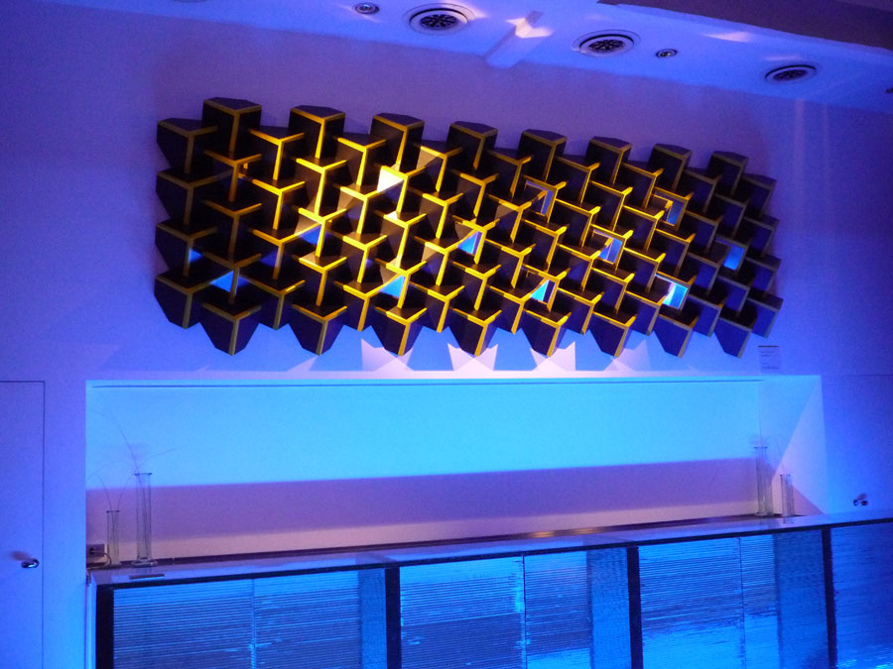

Cuspidi Tela
(Canvas Cusps)
2010
Canvas on MDF support
145 x 155 cm
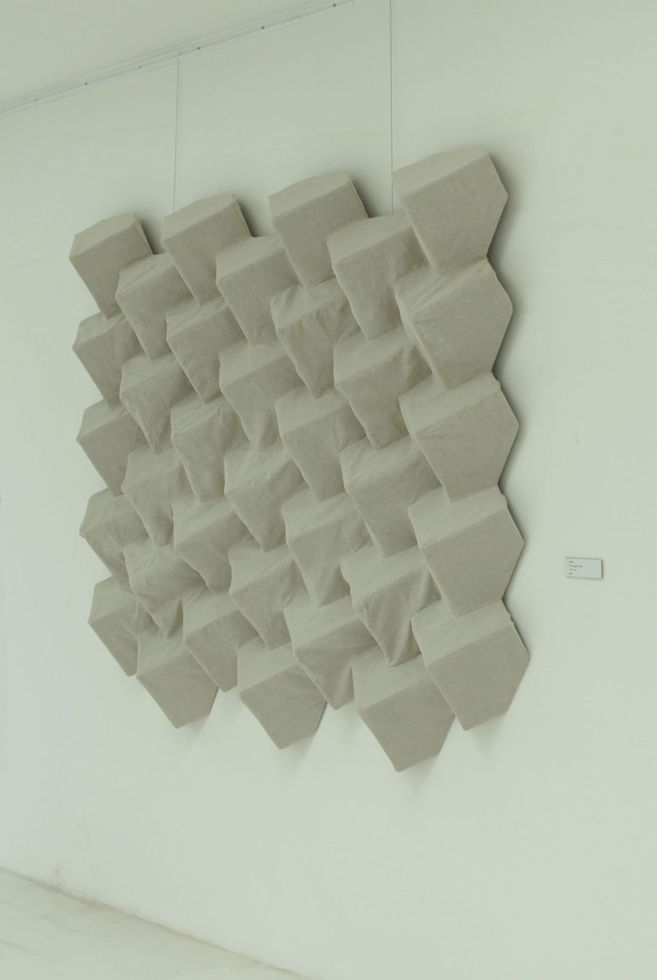

Cuspidi #1
(Cusps #1)
2007
Print on forex
180 x 110 cm


Cuspidi N/G
(N/G Cusps)
2009
Acrilic on pywood and stainless steel inserts
90 x 210 cm
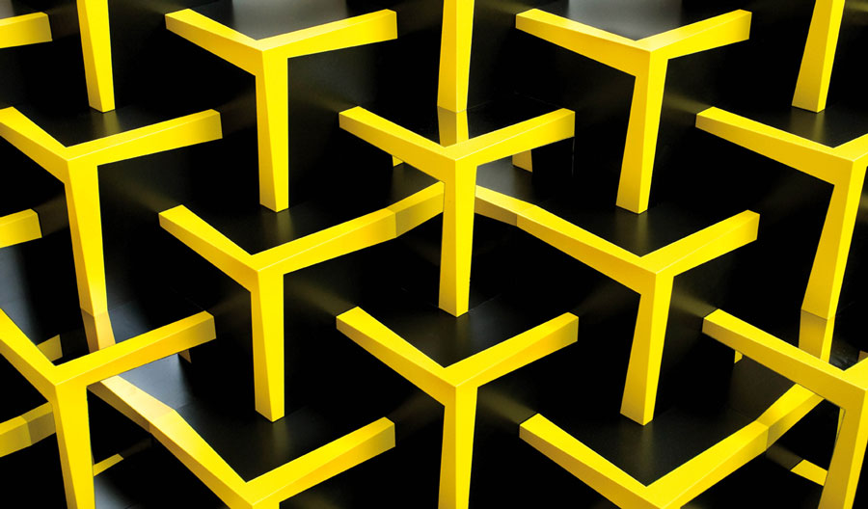

Cuspidi R/B
(R/B Cusps)
2009
Acrilic on steel
120 x 200 cm
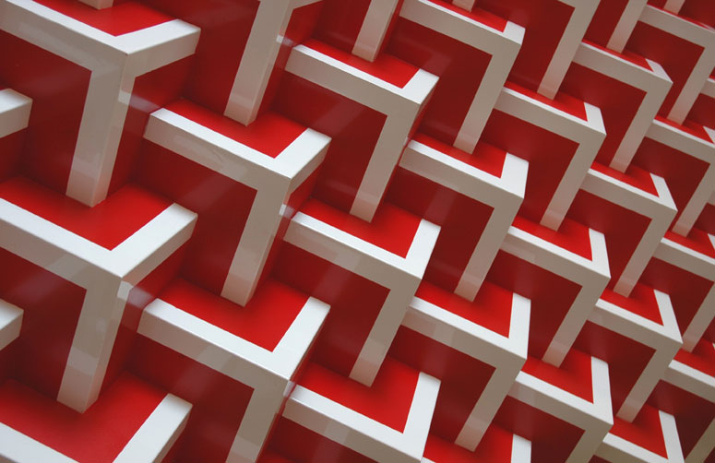

Cuspidi Bianche
(White Cusps)
2010
Catalytic paint on aluminum
120 x 200 cm
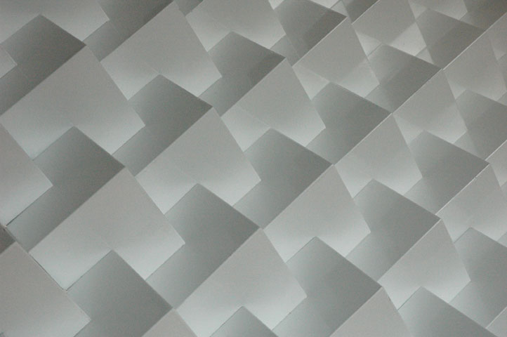

INSTALLATION Site specific
for the Lu.C.C.a. Museum of Contemporary Art

2010
Epson print application plexiglass back with aluminum support
110 x 165 cm


